UNIVERSITY OF BARISHAL

Course Title: Computer Fundamentals and Office

Applications

Batch: 50

Roll: 01-50-16

Assignment Topic: Impact of Environment Pollution on Earth

Submitted To Submitted By

Md. Rashid Al Asif Name: Tithi Biswas

Assistant Professor Roll: 01-50-16

Department of CSE Department of Public Administration

University of Barishal University of Barishal

Contents

**Abstract:** 4

Introduction: 4

❖ Components of Environment 4

❖ Different Aspects of Environmental Pollution 4

➢ Air Pollution 4

➢ Main Sources of Air Pollution 5

➢ Water Pollution 6

➢ Main Sources of Water Pollution 6

➢ Noise Pollution 8

Causes of Noise Pollution 8

❖ Effects of Environment Pollution 10

❖ GOVERNMENTAL STEPS FOR POLLUTION CONTROL IN BANGLADESH 11

1. National Environmental Management Action Plan (NEMAP)- 12

2. Environmental Acts, Rules and Laws 12

3. Control of Air Pollution 12

4. Banning of Polyethylene Bags 12

5. Urban Transport Project- 12

6. Embargo on Import of Items 12

7. Control of Arsenic Pollution 12

8. Knowledge Enrichment Programme 13

9. Rural Sanitation Programme 13

❖ SUGGESTED STEPS FOR POLLUTION CONTROL 13

1. Use of Environmental Technologies and Methods 13

2. Development of Environmental Database 13

3.Environmental Education and Awareness 14

4. Industrial and Solid Waste Management 14

5. Enforcement of Rules and Regulation 14

6. Urban Transport Management 14

7. Reduce Sulfur in Diesel 14

CONCLUSION 14

References 14

**ENVIRONMENT POLLUTION**

# **Abstract:**

Developmental activities such as construction, transportation and manufacturing not only deplete the natural resources but also produce large amount of wastes that leads to pollution of air, water, soil, and oceans, global warming and acid rains. Untreated or improperly treated waste is a major cause of pollution of rivers and environmental degradation causing ill health and loss of crop productivity. In this research paper a study is undertaken about the major causes of pollution, their effects on our environment and the various measures that can be taken to control such pollutions. (*Environment Pollution of Bangladesh – It’s Effect and Control +8801924122222 | PDF*, n.d.)

# Introduction:

The pollution of the environment and its natural resources such as water, air or land with different pollutants is known as environmental pollution. The biggest and main harmful effect of pollution is on the environment as it breaks up the environment and also the different ecosystems present in it. It has adverse effects on both the humans and the other environmental living and non-living things. It is a worldwide problem and it causes hazardous effects on humans and natural resources. Environmental pollution is defined as the state of contamination of different natural resources of the environment with the introduction of the poisonous chemicals and gases in the atmosphere of the earth which leads towards the destruction of natural resources of the environment such as land, air or water. The different pollutants which pollute the environment may be regarded as primary or secondary pollutants and the pollutants having short term or long-term effects on the environment due to their vitality and nature of causing damage to the environment. It is the state of the buildup of toxic chemicals and poisonous gases in the breathing zone of the atmosphere of the earth which leads to many harmful disorders and discomforts to all the life species relying on natural resources of the environment. (*(PDF) Impact of Pollution on Environment and Health*, n.d.)

* 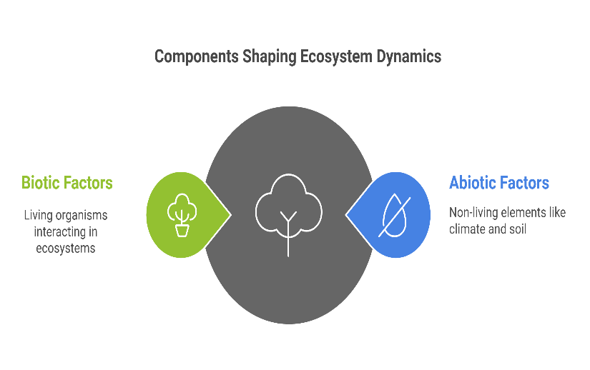Components of Environment**:**
* 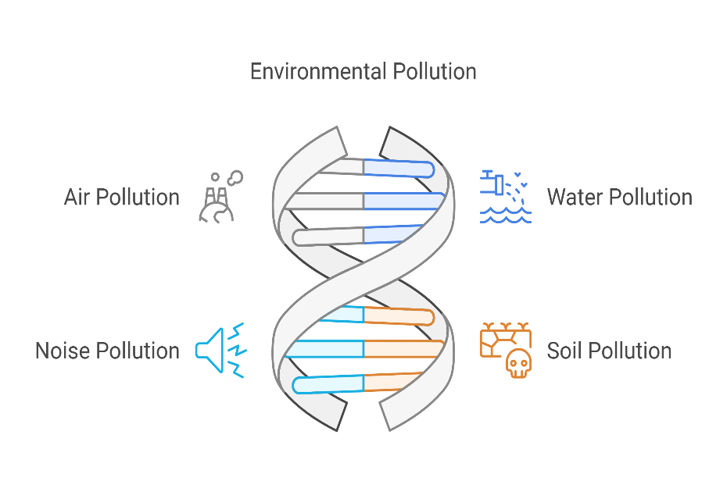Different Aspects of Environmental Pollution**:**
* Air Pollution**:**

Air pollution is a serious environmental health hazard affecting the populations of Bangladesh. Air pollution of Bangladesh is caused due to increasing population and associated motorization. Indoor air pollution is mainly associated with the use of biomass fuels during cooking with poor ventilation. Industrial emissions and automobiles are the principle sources of outdoor air pollution. The national ambient air quality standards of Bangladesh and amount of pollutants in the air of Dhaka city is shown below:

**Table 1: Bangladesh National Ambient Air Quality Standards**

|  |  |  |  |  |
| --- | --- | --- | --- | --- |
| Land Use Category | 8-hour average concentration in ug/m3 | | | |
| CO | NO2 | SPM | SO2 |
| Industrial/Mixed Use | 5000 | 100 | 500 | 120 |
| Commercial/Mixed Use | 5000 | 100 | 400 | 100 |
| Residential/Rural Use | 2000 | 80 | 200 | 80 |
| Sensitive Use* | 1000 | 30 | 100 | 30 |

Sensitive Areas include national monuments, health resorts, hospitals, archeological spots and educational institutions.

*Source: Department of Environment (DOE),1997.*

**Table 2: Pollutants in the Air of Dhaka City**

|  |  |  |  |  |
| --- | --- | --- | --- | --- |
| Location at Dhaka City | Sulfur Dioxide (SO2) | | Nitrogen Dioxide(NO2) | |
| Concentration  (ug/m3) | Permissible  (ug/m3) | Concerntration  (ug/m3) | Permissible  (ug/m3) |
| Gulistan | 800 | 100 | 500 | 100 |
| Jatrabari | 1300 | 500 |
| Pantho-Poth | 900 | 500 |
| Mohakhali | 1200 | 500 |

* 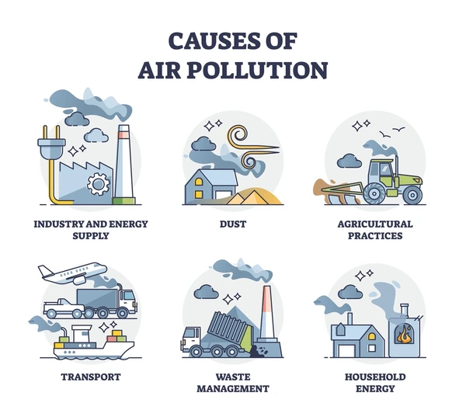Main Sources of Air Pollution**:**

1. **Burning Fossil Fuel-** Air pollution mainly occurs due to burning of fossil fuels like coal, petroleum etc and associated black smoke. Over 99% of the brick kilns use fossil fuel but don't comply with the "Brick Kiln Ordinance" and pollute enormous air.

**2. Industrial Discharge-** Industries cause air pollution through smoke emission. Agro based industries like sugar, pulp, paper, tanneries and value added industries like textile, garments, pharmaceutics, oil refineries, fertilizer and chemical industries are the major contributors for air pollution. The air pollution percentage of most five industrial sectors of Bangladesh in the year 2001 is shown below:

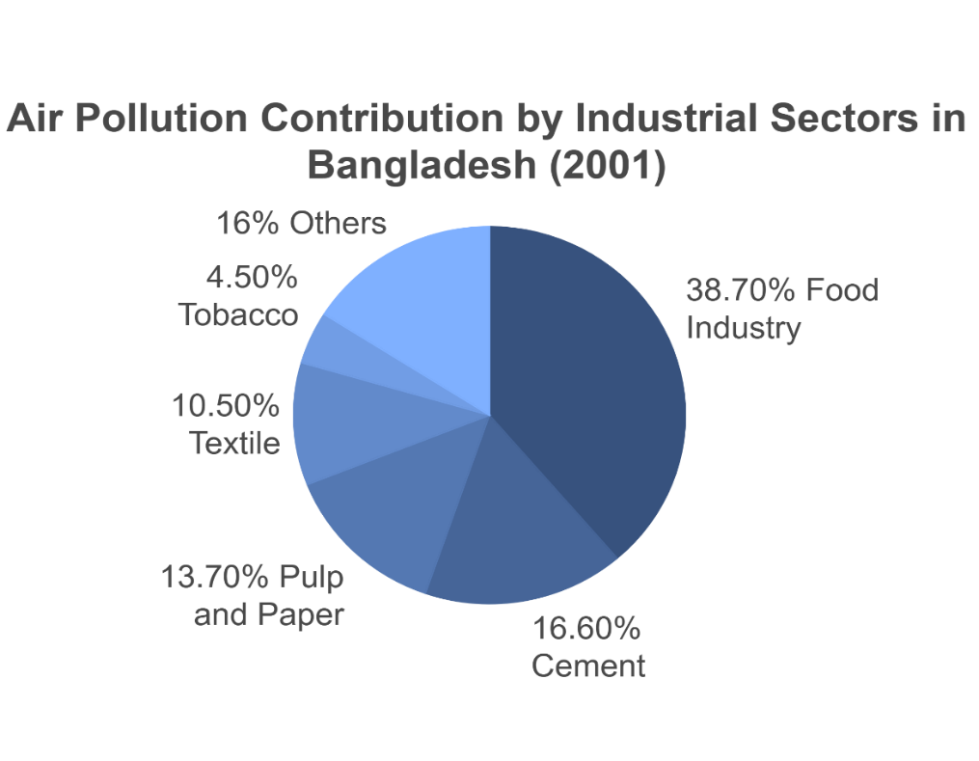

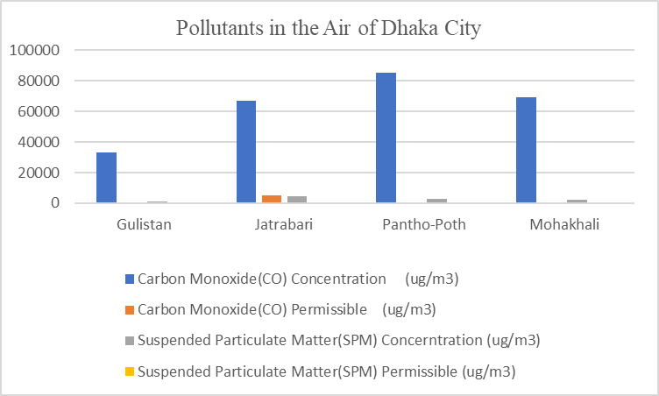

* Water Pollution**-**Water pollution creates serious health hazard for Bangladesh. The dumping of municipal wastes, hospital wastes and toxic environmental discharges from mostly industries pollute both surface and ground water sources. The most dangerous threat emanating from environmental degradation is the arsenic contamination of ground water.
* Main Sources of Water Pollution**-**



**1.Industrial Waste and Effluent-** The main industrial areas of Bangladesh are at Dhaka, Chittagong, Khulna, and Bogra districts. The mostly contributing industries for water pollution are pulp and paper, pharmaceuticals, metal processing, food industry, fertilizer, pesticides, dyeing and painting, textile, tannery etc. More than 200 rivers of Bangladesh directly or indirectly receive a large quantity of untreated industrial wastes and effluent. Everyday approximately 700 tanneries of Dhaka city are discharging about 16,000 cubic meters of toxic wastes. The Department of Environment (DOE) has listed 1,176 factories that cause pollution throughout the country. Water pollution percentage of most five industrial sectors of Bangladesh in the year 2001 is shown below-

*Table-3: Water Pollution Percentage of most Five Industrial Sectors of Bangladesh in the Year 2001*

|  |  |  |
| --- | --- | --- |
| Industry | Emission (Tons/Yr) | Pollution (%) |
| Pulp and Paper | 91768.10 | 47.4% |
| Pharmaceuticals | 30866.72 | 15.9% |
| Metal | 27174.61 | 14.0% |
| Food Industry | 23403.39 | 12.1% |
| Fertilizers/Pesticides | 12715.00 | 6.6% |

*Source: Research Work by Islam Faisal on Industrial Pollution in Bangladesh in the year 2002*

**2.Solid Waste and Sewage Disposal-** The indiscriminate discharge of solid waste, domestic and hospital sewage are the major source of water pollution in Bangladesh. About 4,000 to 4,500 tons of solid wastes are generated daily and only half of the generated wastes are disposed of in low lying areas or into river water. These solid wastes are associated with the problems of littering on roads, spilling around the bins, clogging of drains, indiscriminate dumping on vacant plots and cause serious environmental pollution. More than 500 hospitals and clinics of Dhaka city generate and release hazardous and toxic wastes without any treatment. The generated solid waste of six famous hospitals / clinics of Dhaka city is shown below:

*Table-4: Solid Waste Generation from Six Famous Hospitals/Clinics of Dhaka City*

|  |  |  |  |  |  |
| --- | --- | --- | --- | --- | --- |
| Name of  Hospital/Clinic | Generated Waste  (kg/bed day) | Non- hazards waste | | Hazards Waste | |
| Qty | % of Total Waste | Qty | % of Total Waste |
| DMCH | 1.19 | 1.07 | 90 | 0.12 | 10 |
| SSMCH | 1.23 | 1.09 | 89 | 0.14 | 11 |
| RIHD | 1.20 | 0.91 | 76 | 0.29 | 24 |
| HFRCH | 1.59 | 1.29 | 81 | 0.30 | 19 |
| DNMCH | 0.80 | 0.70 | 88 | 0.10 | 12 |
| SAHL | 0.83 | 0.72 | 87 | 0.11 | 13 |

***Source: M Shehab Ullah on “A study of hospital waste management in Dhaka City” in the year 1999***

**3.Inadequate Sanitary Facilities-** Inadequate sanitation facilities pose a serious environmental threat in Bangladesh. Dhaka Water and Sewerage Authority (DWASA) can serve only for 15 to 20% of city population. In absence of the sanitation and infrastructural services, 40% having septic tank and soak pit, 15% using pit latrines and 30% using open latrines. The sewage is mostly released into low-lying areas and river water in untreated manner causing great environmental hazards.

* Noise Pollution**-**



The noise pollution is also a major health hazard in Bangladesh. According to World Health Organization (WHO), 60 decibel (DB) sound can make a man deaf temporarily and 100 DB sound can cause complete deafness. According to the Department of Environment (DOE), the perfect sound. condition for Bangladesh is 45 dB for the daytime and 35 dB for the night in peaceful areas and 50 dB for the daytime and 40 dB for the night in residential areas. The main sources of noise pollution are industries, motorized vehicles, construction works and indiscriminate use of loudspeaker. At present noise level in Dhaka city are estimated ranging from 60 to 100 decibel. If present situation continues then by the year 2017, 50% people of Dhaka city will loss 30 decibel of hearing power. The daily variation of noise level near the road at some of the key locations of Dhaka city is shown below:

|  |  |  |  |
| --- | --- | --- | --- |
| Time Interval | Location | | |
| **Gulistan** | **Science-Lab** | **Saydabad** |
| **Commercial** | **Mixed** | **Commercial** |
| 7am-11am | **80.08** | **76.24** | **83.27** |
| 11am-3pm | **79.34** | **75.19** | **83.89** |
| 3pm-7pm | **81.13** | **77.23** | **84.37** |
| 7pm-1pm | **78.52** | **75.32** | **82.08** |

*Source: Nazmul Chowdhury research on noise pollution in Dhaka City on Feb 2002*

Causes of Noise Pollution**:**

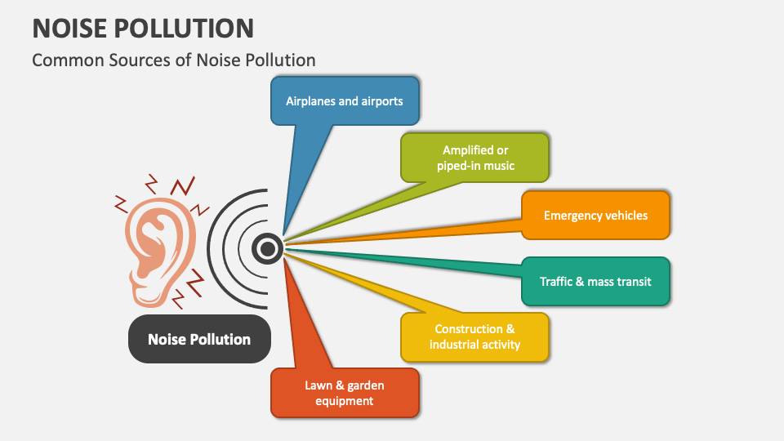

* **Soil pollution:** Apart from earthquakes, erosion, and other natural disasters that tend to damage the soil, the main sources of soil contamination are industrial and domestic wastes. Some soil pollutants include heavy metals, hydrocarbons, inorganic and organic solvents. Dumping of refuse on open land, waste burning, and inadequate landfills are the major contributors to soil pollution. Fossil fuels from petrochemical plants, petroleum refineries, and power-generating plants also support soil pollution. Petroleum exploration, refining, and distribution through road transport often result to soil pollution. Pollution of land by plastics is beginning to receive global attention due in part to the toxic nature of the additives used in their production and direct effects plastics have on plants and animals. Plastic litter on land is unpleasant to the eyes, may penetrate into the soil and prevent nutrient uptake by plants, and cause entanglement of terrestrial animals. Pollution of soil does not only result in human health problems but also may modify metabolic processes in plants resulting in reduced crop yields. Pollutants may equally find their way into the food chain through absorption by plants. (Holdgate, 1979)

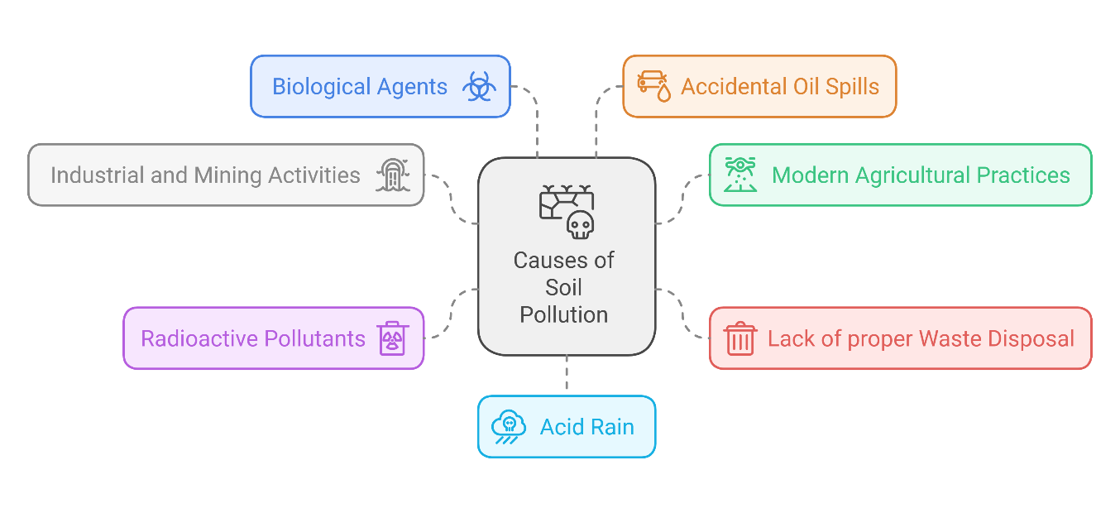

* 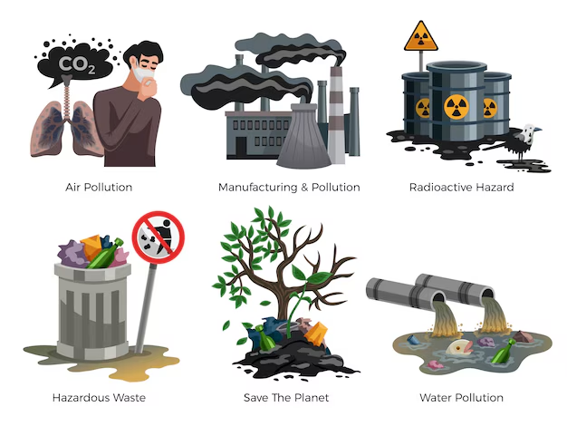Effects of Environment Pollution**:**

1. Severe environmental pollution is threatening human health and economic growth of Bangladesh. Air pollution mostly affects the urban children. Indoor air pollution is a greater threat to health than outdoor air pollution. Bangladesh could avoid 10,000 deaths and save between 200 and 500 million dollars a year if indoor air pollution in four major cities can be reduced to acceptable limits.

2. Immediate effect of smoke inhalation causes headache, vertigo, burning sensation of the eyes, sneezing, nausea, tiredness, cough etc. It's long term effect may cause asthma and bronchitis. Lead affects the circulatory, nervous and reproductive systems as well as affects kidney and liver including liver cancer or cirrhosis. Carbon monoxide hampers the growth and mental development of an expected baby. Nitrogen oxides cause bronchitis and pneumonia.

3. Industrial emissions cause different waterborne disease and damage to health. Arsenic poisoning is slow and cumulative. It causes melanosis, kurtosis and conjunctivitis. Subsequently respiratory problem, gangrene, skin, kidney and lung cancer would arise. The Arsenic effect not only causes. serious health hazards but also creates a widespread social problem. The inadequate sanitation facilities also pose a serious health threat in Bangladesh.

4. Noise pollution causes mental and physical illness among the people. Sound pollution causes deafness to heart attack. Any sort of noise pollution seriously affects expecting mothers. It also causes high blood pressure, tachycardia, headache, indigestion, and peptic ulcer.

5. Many people died every year in many diseases due to environmental pollution. The death rate in the year 1996 mainly due to environmental pollution is as follows.

***Table-5: The death rate in the year 1996 due to environmental pollution***

|  |  |  |
| --- | --- | --- |
| *Causes of Death* | *National Level* | *Dhaka City* |
| *Death: All Ages (%)* | | |
| *Cardiovascular* | ***7.87*** | ***17.5*** |
| *Asthma* | ***5.2*** | ***4.3*** |
| *Diarrhea* | ***1.66*** | ***7.8*** |
| *Cancer* | ***4.05*** | ***5.3*** |
| *Dysentery* | ***4.05*** | ***5.5*** |
| *Viral Hepatitis* | ***2.14*** | ***3.4*** |
| *Death Less than One Year Infant (%)* | | |
| *Anemia* | ***4.77*** | ***6.5*** |
| *Breathing Problem* | ***1.87*** | ***2.8*** |
| *Diarrhea* | ***18.96*** | ***17.5*** |
| *Cancer* | ***4.05*** | ***5.0*** |
| *Dysentery* | ***1.66*** | ***3.9*** |
| *Viral Hepatitis* | ***2.14*** | ***3.4*** |

* GOVERNMENTAL STEPS FOR POLLUTION CONTROL IN BANGLADESH**-**

The Ministry of Environment and Forest (MOEF)' of Bangladesh is primarily responsible for environmental protection. It was created in 1989. The MOEF has taken some steps to control the environmental pollution of Bangladesh-

1. National Environmental Management Action Plan (NEMAP)- The government has taken a project named NEMAP to integrate environment with the development in a policy framework. It provides a guideline for promoting effective management of resources, raising awareness among the people and improvement of environmental degradation.

2. Environmental Acts, Rules and Laws**-**The government of Bangladesh has modified environmental acts, rules and laws to improve environmental condition. Environment court has already been established to take prompt legal action against environmental pollution. The DOE has been empowered to punish the offenders of environmental rules.

3. Control of Air Pollution-Recently the DOE has taken some measures to carry out surveys on identification and control of polluting industries, protecting habitats, examining the use of compressed natural gas in industries, setting environmental standards and controlling river and automobile pollution on environmental management. It also conducts vehicular emission measurements at Dhaka city.

4. Banning of Polyethylene Bags- Most of the sewage lines of Dhaka city have been blocked by indiscriminate dumping of polyethylene bags over the years. As such, the government has banned the production, marketing and use of polyethylene bags up to 20 microns thick or less from 01 March 2002.

5. Urban Transport Project- A Urban Transport Project has been launched by the Government to improve traffic system, envisage good bus services, improve road networks by constructing over-bridges, fly-overs, underpasses and envisages a positive role for non- motorized transport.

6. Embargo on Import of Items**-** The government has banned the import of leaded petrol, high sulfur diesel and high sulfur coal. The government has also encouraged to use Compressed Natural Gas (CNG) to the automobiles. Bangladesh Road Transport Authority (BRTA) has restricted the registration on two stroke three wheelers.

7. Control of Arsenic Pollution**-** The Government has taken four Strategies to mitigate the arsenic problem. These are as follows:

(a). Immediate detection of the arsenic effected patients and ensure their proper treatment.

(b). Identify the arsenic contaminated tube wells, labeled them with red colour for danger ones and green with safe ones.

(c). Detect the reasons for arsenic contamination in soil water and find out the sources of safe drinking water.

(d). Conduct health education campaigns and grow awareness among the people.

8. Knowledge Enrichment Programme**-** Environmental education program has been incorporated in primary and higher education. Many universities have introduced various curriculum and projects on environmental issue. Government organizations as well as NGOs present meetings and seminars to arise public awareness on the environmental issue.

9. Rural Sanitation Programme**-** The Bangladesh Government has taken a rural sanitation programme from October 2003 to implement the facilitation, construction and installation of twin pit latrine. It improves rural sanitation coverage and reduces infectious diseases in rural areas. (Manisalidis et al., 2020)

* SUGGESTED STEPS FOR POLLUTION CONTROL**:**

The government has taken some steps to improve the pollution control of Bangladesh. But the steps are not adequate. As such, few more steps may also be taken to improve the environmental degradation-

1. Use of Environmental Technologies and Methods**-** Environmental technologies and methods such as Geographic Information Systems (GIS), remote sensing and environmental impact assessment might be used for integrated policy formulation, decision-making, evaluation and monitoring of environment.

2. Development of Environmental Database**-**A comprehensive environmental database may be made and the environmental planners might have the access for environmental up-gradation, planning and management The database is to be updated regularly.

3.Environmental Education and Awareness**-** Formal and informal methods of education might be adopted through local media, seminars, celebrations, workshops, walks and student competitions to aware the people regarding the process of environmental degradation.

4. Industrial and Solid Waste Management**-** The government might take appropriate measures to monitor emission limits and Market Based Incentives (MBI) for reducing pollution control. The industries might be given both technical and financial support for introducing mitigation measures, promoting green technologies, using less pollution technologies and recycling the waste. (Chu & Karr, 2017)

5. Enforcement of Rules and Regulation**-** Environmental Conservation Rules of 1997, traffic rules and other relevant environmental laws might be enforced further to punish the violation of the emission limits. (Gardner & Stern, n.d.)

6. Urban Transport Management**-** Government must strengthen vehicle emission standards, complete the emission inventory and conduct an investigation on the emission control measures. Auto-rickshaw must be restricted in Dhaka city. Government must replace old vehicles, two-stroke engine vehicles, improve traffic conditions and promote an equivalent and efficient alternative public transportation management. services to improve urban transport. (Liang et al., 2019)

7. Reduce Sulfur in Diesel**-** Government must take necessary steps to remove sulfur content from diesel through hydro-desulphurization (HDS) process. The government must also enforce the vehicle manufacturers to install catalytic converters in every vehicle to reduce the vehicular emissions. (Al-Dulaimi & Al-Taai, 2021)

# CONCLUSION

Environmental issues have become a major concerns due to impact on public health and development of Bangladesh. Air and water pollution, groundwater contamination, nuisance from solid wastes and noise pollution are the main environmental pollutions of Bangladesh. Dhaka City is one of the most polluted cities in the world. Environmental problems occur mainly due to population growth, urbanization, industrialization, rapid rise in transportation, inadequate and improper traffic management, poor sanitation systems and inefficient solid waste management.

References**:**

Al-Dulaimi, W. A. M., & Al-Taai, S. H. H. (2021). Pollution and its Impact on Sustainable Development. *IOP Conference Series: Earth and Environmental Science*, *790*(1), 012025. https://doi.org/10.1088/1755-1315/790/1/012025

Chu, E. W., & Karr, J. R. (2017). Environmental Impact: Concept, Consequences, Measurement. *Reference Module in Life Sciences*, B978-0-12-809633-8.02380-3. https://doi.org/10.1016/B978-0-12-809633-8.02380-3

*Environment pollution of bangladesh – it’s effect and control +8801924122222 | PDF*. (n.d.). Retrieved December 14, 2024, from https://www.slideshare.net/slideshow/environment-pollution-of-bangladesh-its-effect-and-control/28771650

Gardner, G. T., & Stern, P. C. (n.d.). *ENVIRONMENTAL PROBLEMS and HUMAN BEHAVIOR*.

Holdgate, M. W. (1979). *A Perspective of Environmental Pollution*. CUP Archive.

Liang, L., Wang, Z., & Li, J. (2019). The effect of urbanization on environmental pollution in rapidly developing urban agglomerations. *Journal of Cleaner Production*, *237*, 117649. https://doi.org/10.1016/j.jclepro.2019.117649

Manisalidis, I., Stavropoulou, E., Stavropoulos, A., & Bezirtzoglou, E. (2020). Environmental and Health Impacts of Air Pollution: A Review. *Frontiers in Public Health*, *8*. https://doi.org/10.3389/fpubh.2020.00014

*(PDF) Impact of Pollution on Environment and Health: An Investigation*. (n.d.). ResearchGate. Retrieved December 14, 2024, from https://www.researchgate.net/publication/276866919_Impact_of_Pollution_on_Environment_and_Health_An_Investigation